**z SAVEETHA SCHOOL OF ENGINEERING**

**SAVEETHA INSTITUTE OF MEDICAL AND TECHNICAL SCIENCES**

**INSTITUTE OF COMPUTER SCIENCE ENGINEERING**

**MANAGEMENT INFORMATION SYSTEMS**

**K.VENKATA TEJASRI**

**192111682**

1. **Draw a Use case diagram to model for a quiz system. A user can request a quiz for the system. The system picks a set of questions from its database, and composes them together to make a quiz. It rates the user’s answers and gives hints if the user requests it. In addition to users, we also have helpers who provide questions and hints. And also, administrators who must certify questions to make sure they are not too trivial, and that they are correct.**

**USECASE DIAGRAM:**

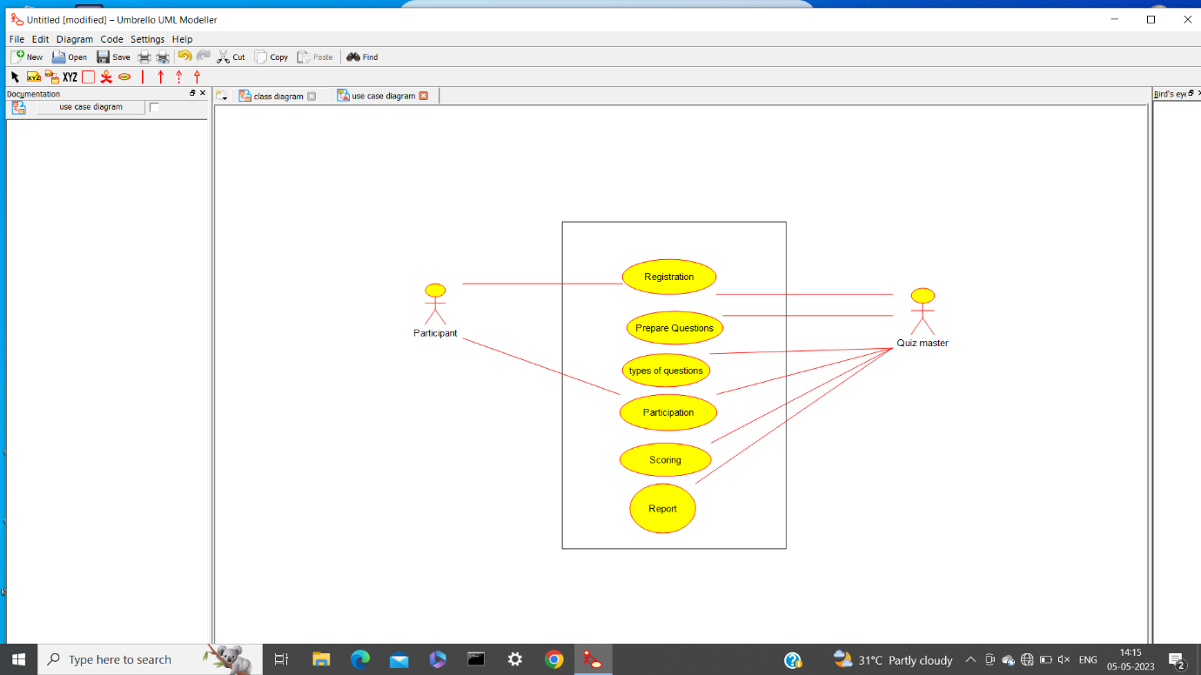

1. **Draw a UML diagram for online purchasing system. Provide top level use cases for a web customer making purchases online. Web customer actor uses some web site to make purchases online. Top level use cases are View Items, Make Purchase and Client Register.**

**USECASE DIAGRAM:**

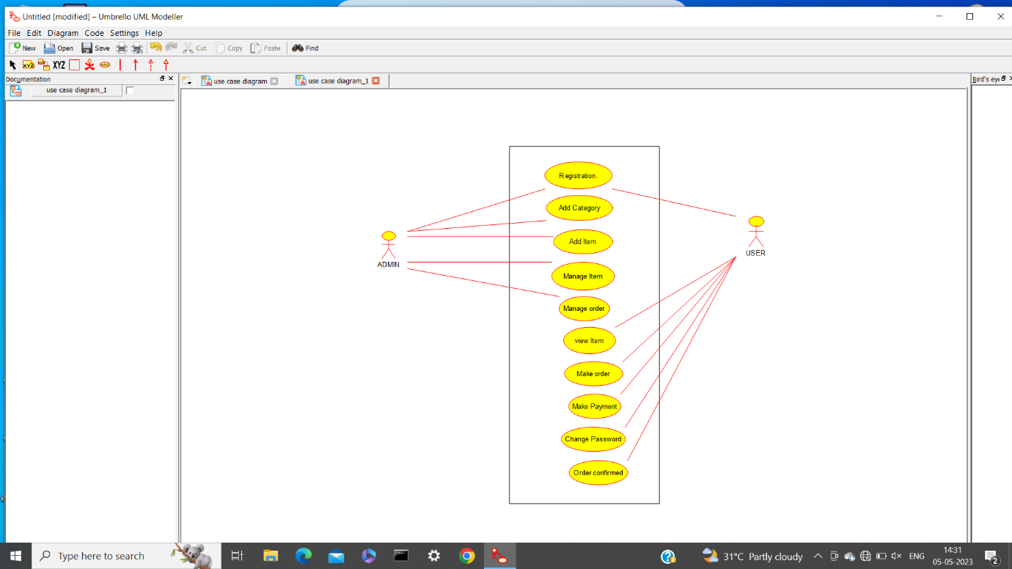

3) Describe major services (functionality) provided by a hospital's reception.

Summary: Hospital Management System is a large system including several subsystems or

modules providing variety of functions. Hospital Reception subsystem or module supports some of the many job duties of hospital receptionist. Receptionist schedules patient's appointments and admission to the hospital, collects information from patient upon patient's arrival and/or by phone.

Draw a UML diagrams for this HMS. For the patient that will stay in the hospital ("inpatient") she or he should have a bed allotted in award. Receptionists might also receive patient'spayments, record them in a database and provide receipts, file insurance claims and medical reports.

USECASE DIAGRAM:

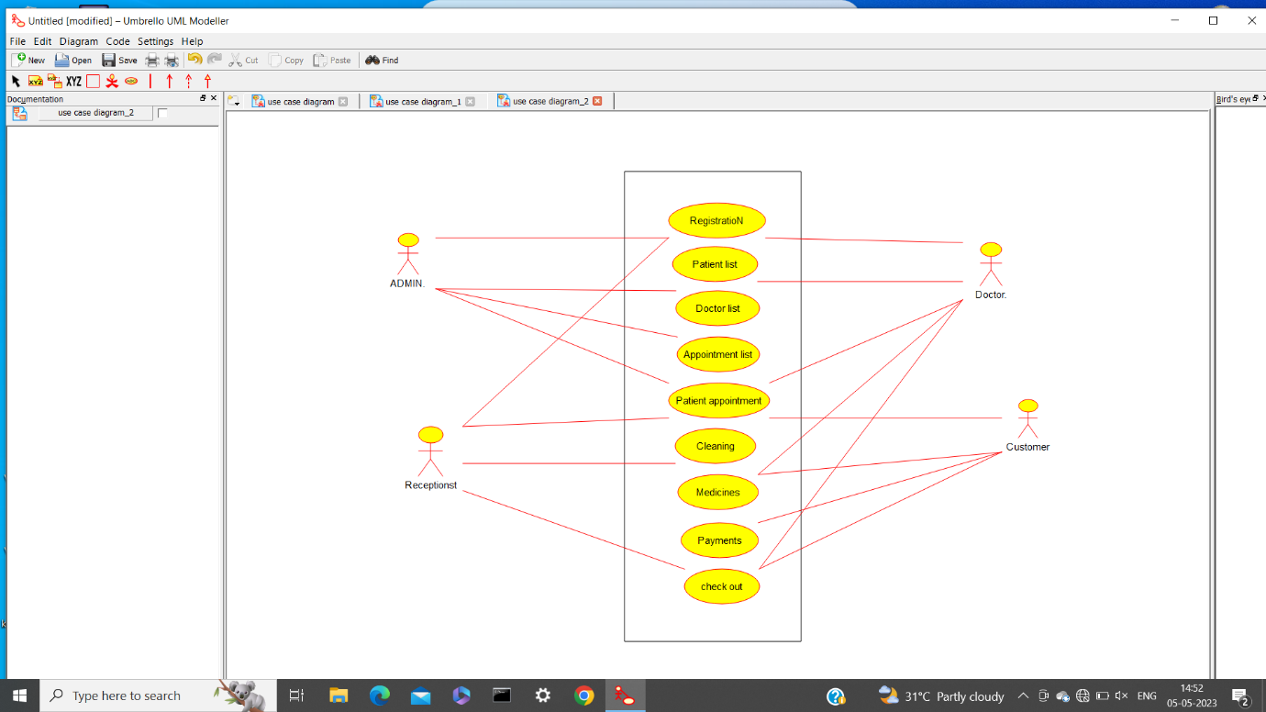

4) A college has more than thousand security persons, who are instructed to give duties at

different places within the campus. Additionally, they also maintain a routine, which contains all

information, such as Date, Duty Start Time, Duty End Time, and Place. Most importantly, all the

places are covered by at least one security person. If a security person takes leave, manual entry is

done against that person. Finally, at the end of a month, the security persons get paid for their

duties, while considering the number of leaves as well. You can see that the manual calculation/operation is a heavy task for the security manager. Therefore, the objective is to build

an Online security management system using class diagram through which entire security system

within the campus can be controlled in an efficient manner.

USECASE DIAGRAM:

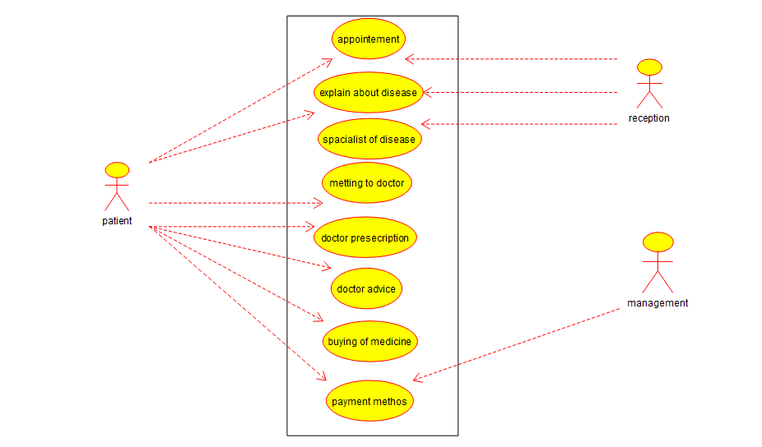

5) Draw a use case diagram for Library Management System is an automation system used to

manage a library and the different resource management required in it like cataloguing of books,

allowing check out and return of books, invoicing, user management, etc. The user can search for books details using few book properties (Book ID, Title, Author, and Publisher). Searching

should return details about all the book copies that match the search query.

USECASE DIAGRAMS:

